**2.10 View a Preset Report**

1. Log On to the System (see 2.2).

2. Click the “Reports” tab in the Navigation Bar to get to the Reports Page:

3. Select one of the Preset Reports from the dropdown list.

4. Click the "Generate Preset Report" link under the dropdown.

5. The report will be created and displayed under the report parameters area.

**2.11 Generate a Custom Report**

1. Log On to the System (see 2.2) and go to the Reports Page (see section 2.10).

2. Click one of the Chart Type images located in the custom report section to select that Chart.

Note: The Heat Map is always displayed as a Print-Friendly Version. See 2.13.

3. Select the Field to compare by.  
4. Select which items in that Field to include, or click "Select All" to check all the boxes (and uncheck any you wish not to include.)

5. If desired, constraints can selected for specific filtering. All of the advanced filters default to include all possible information.

6. Select the start and end dates for the data to be compiled in the report from the appropriate dropdowns.

7. Click “Generate Report.” The report will be created and displayed under the report parameters area.

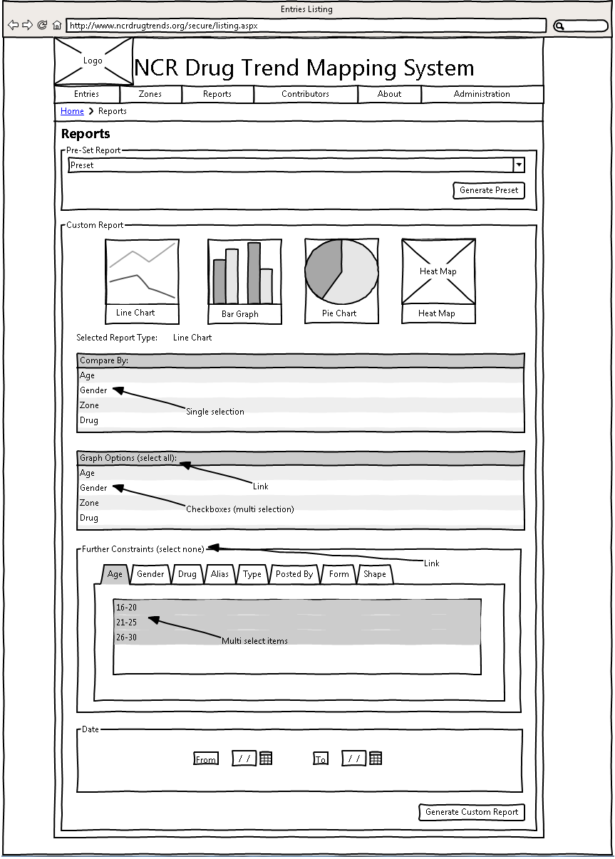

Figure 10: Report Page Options

**2.12 Modify Report Parameters**

1. Log on to the system and generate a report (see section 2.10).

2. The report parameters area will still be present over the generated report. Change any of the report parameters desired and click “Generate Report” again to view the report with the modified parameters.

**2.13 View Print Friendly Report**

1. Log on to the system and generate a report (see section 2.10).

2. Click the “View Print Friendly Version” button under the Chart.

3. You will be redirected to the print-friendly version page:

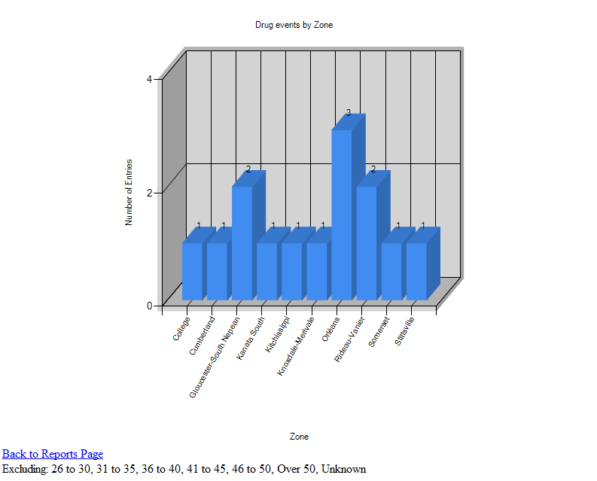

Figure 12: Report Comparison

4. This version of the report does not display the DTMS site header and navigation bar, and the text is unformatted. This makes it a cleaner, more elegant version to save or print to view later. The print friendly version can also be shared with another contributor by copying the URL in the Address Bar and sending it to them in a message or email.

5. If desired, click "View" for any Entry in the Included Entries View. This will show the detailed view of that Entry. Click the Back button in your browser to return to the Print Friendly Report.

6. When finished, click "Back to Reports Page" or the back button in your browser to return to the Reports Page.